**Graphics Lies, Misleading Visuals**

1. Read Alberto Cairo’s work, [Graphics Lies, Misleading Visuals](http://infovis.fh-potsdam.de/readings/Cairo2015.pdf) Locate an example of a misleading visual that uses one or more of the mechanisms for misleading that Cairo outlines in his book chapter: (1) Hiding relevant data; (2) Displaying too much data and obscuring reality; (3) Distorting data through visual forms.

Please upload an image of this visual using a widely accessible graphic format (e.g., PDF, .jpg, .png)

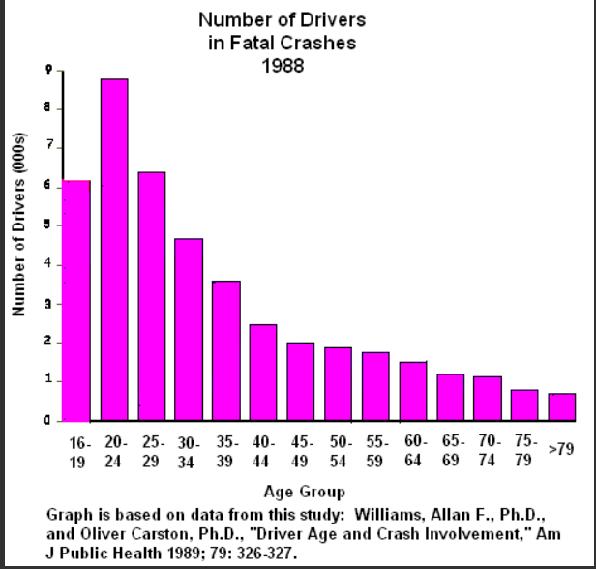

2. Briefly describe the context for the visual by addressing the following questions:

1. What is the source of the visual? (e.g., URL or bibliographic citation)
2. Who is the intended audience (i.e., decoders)? How do you know this?

1) <http://statisticscafe.blogspot.com/2011/12/statistics-can-be-misleading.html>  
  
2) For social researchers who are interested in the stats of car accidents and drivers' age.

3. Finally answer the following questions:

1. Identify the specific component(s) of the visual that is/are misleading
2. For each part(s) of the visualization that is/are misleading, identify the mechanism that is used: hiding relevant data to highlight what benefits us; displaying too much data to obscure reality; using graphic forms in inappropriate ways (distorting the data)
3. Explain how the mechanisms are used to mislead

It suggests that 16-year-olds are safer drivers than people in their twenties, and that octogenarians are very safe. But the figure does not consider how many people are still driving in this age group.